How to set up a WFOE?

What is “WFOE”?
The Wholly Foreign Owned Enterprise, abbreviated WFOE, is a common investment vehicle for mainland China-based business. The unique feature of a WFOE is that involvement of a mainland Chinese investor is not required, unlike most other investment vehicles. WFOEs are limited-liability corporations organized by foreign nationals and capitalized with foreign funds. WFOE's are among the most popular corporate models for non-PRC investors due to their versatility and unique advantages. Such advantages include:

Advantages of WFOE
- Independent operation – Independently carry out parent Company’s global strategy, with no consideration of Chinese partner factors since it is wholly owned nature.
- Total management control within the limitations of the laws of the PRC – The laws include but not limit to “The Law of the People’s Republic of China on Foreign Invested Enterprises”, “Detailed Implementation Rules of the Law of the People’s Republic of China on Foreign Invested Enterprises”, etc.
- Wide range of business scopes – Run the business in the name of the Company, which enable it to perform trading, manufacturing and other activities listed in the Catalogue for the Guidance of Foreign Investments Industries. As an independent Legal Entity, it can receive revenue in RMB, and issue RMB official Fapiaos (receipts) to customers. Meanwhile, it can both receive and remit RMB to the parent company overseas.
- Lower operational cost
  - Rental expense – Grade A office buildings are comparatively a little bit expensive than other business properties which may increase your cost for running the office. For WFOE, there is no such kind of requirement.
  - Taxes – For WFOE, it seems fairer to calculate business tax based on your turnover, while for corporate income tax, if the expenses and costs do not exceed your turnover, no tax will be charged.
  - Employment cost –As a WFOE, you can directly sign labor contracts with your employees.
- Intellectual property & technology know-how protection – Allows you to increase protection of trademarks, intellectual property and technology know-how, in accordance with international law.
- shareholder liability limited to original investment – The liability of a WFOE is limited to the amount of registered capital injected into the business

Documents Required for WFOE Registration
- Copy of Business License of parent foreign company which was certificated by local Chamber of Commerce, notarized, and finally legalized by Chinese Embassy (if it's personal investor, then passport copy should be certificated by Chinese Embassy);
- The latest annual audit report from the parent foreign company. The audit report should be in the format as prepared by a Certified Public Accountant (CPA) ;
- A Credit letter from foreign company banker to declare a good credit within at least current 3 months;
- The resume, copy of the passport and 8 pieces of passport size photos of the Legal Representative of the WFOE, list of the Board of Directors, Supervisor(s);
- The parent company's legal representative's passport copy;
- Feasibility Study Report or business planning of the WFOE setting up by Investor;
- Articles of Association drafted, signed and submitted by Investor;
- In case of a WFOE rent a facility as Registered address, leasing contract, certificate of real estate, and certificate for leasing should be submitted;
The above documents are needed to register a Trading & Consulting WFOE, but if you want to register a Manufacturing WFOE, you have to prepare following extra documents:
- Permission for land use, environment influence evaluation report by a qualified service provider within China;
- Products, size of production, detailed list of equipment;
- Environmental protection measures;
- Requirement for utilities such as power and water supply.

Registration Procedure
Step 1 - Pre-approval of name of WFOE
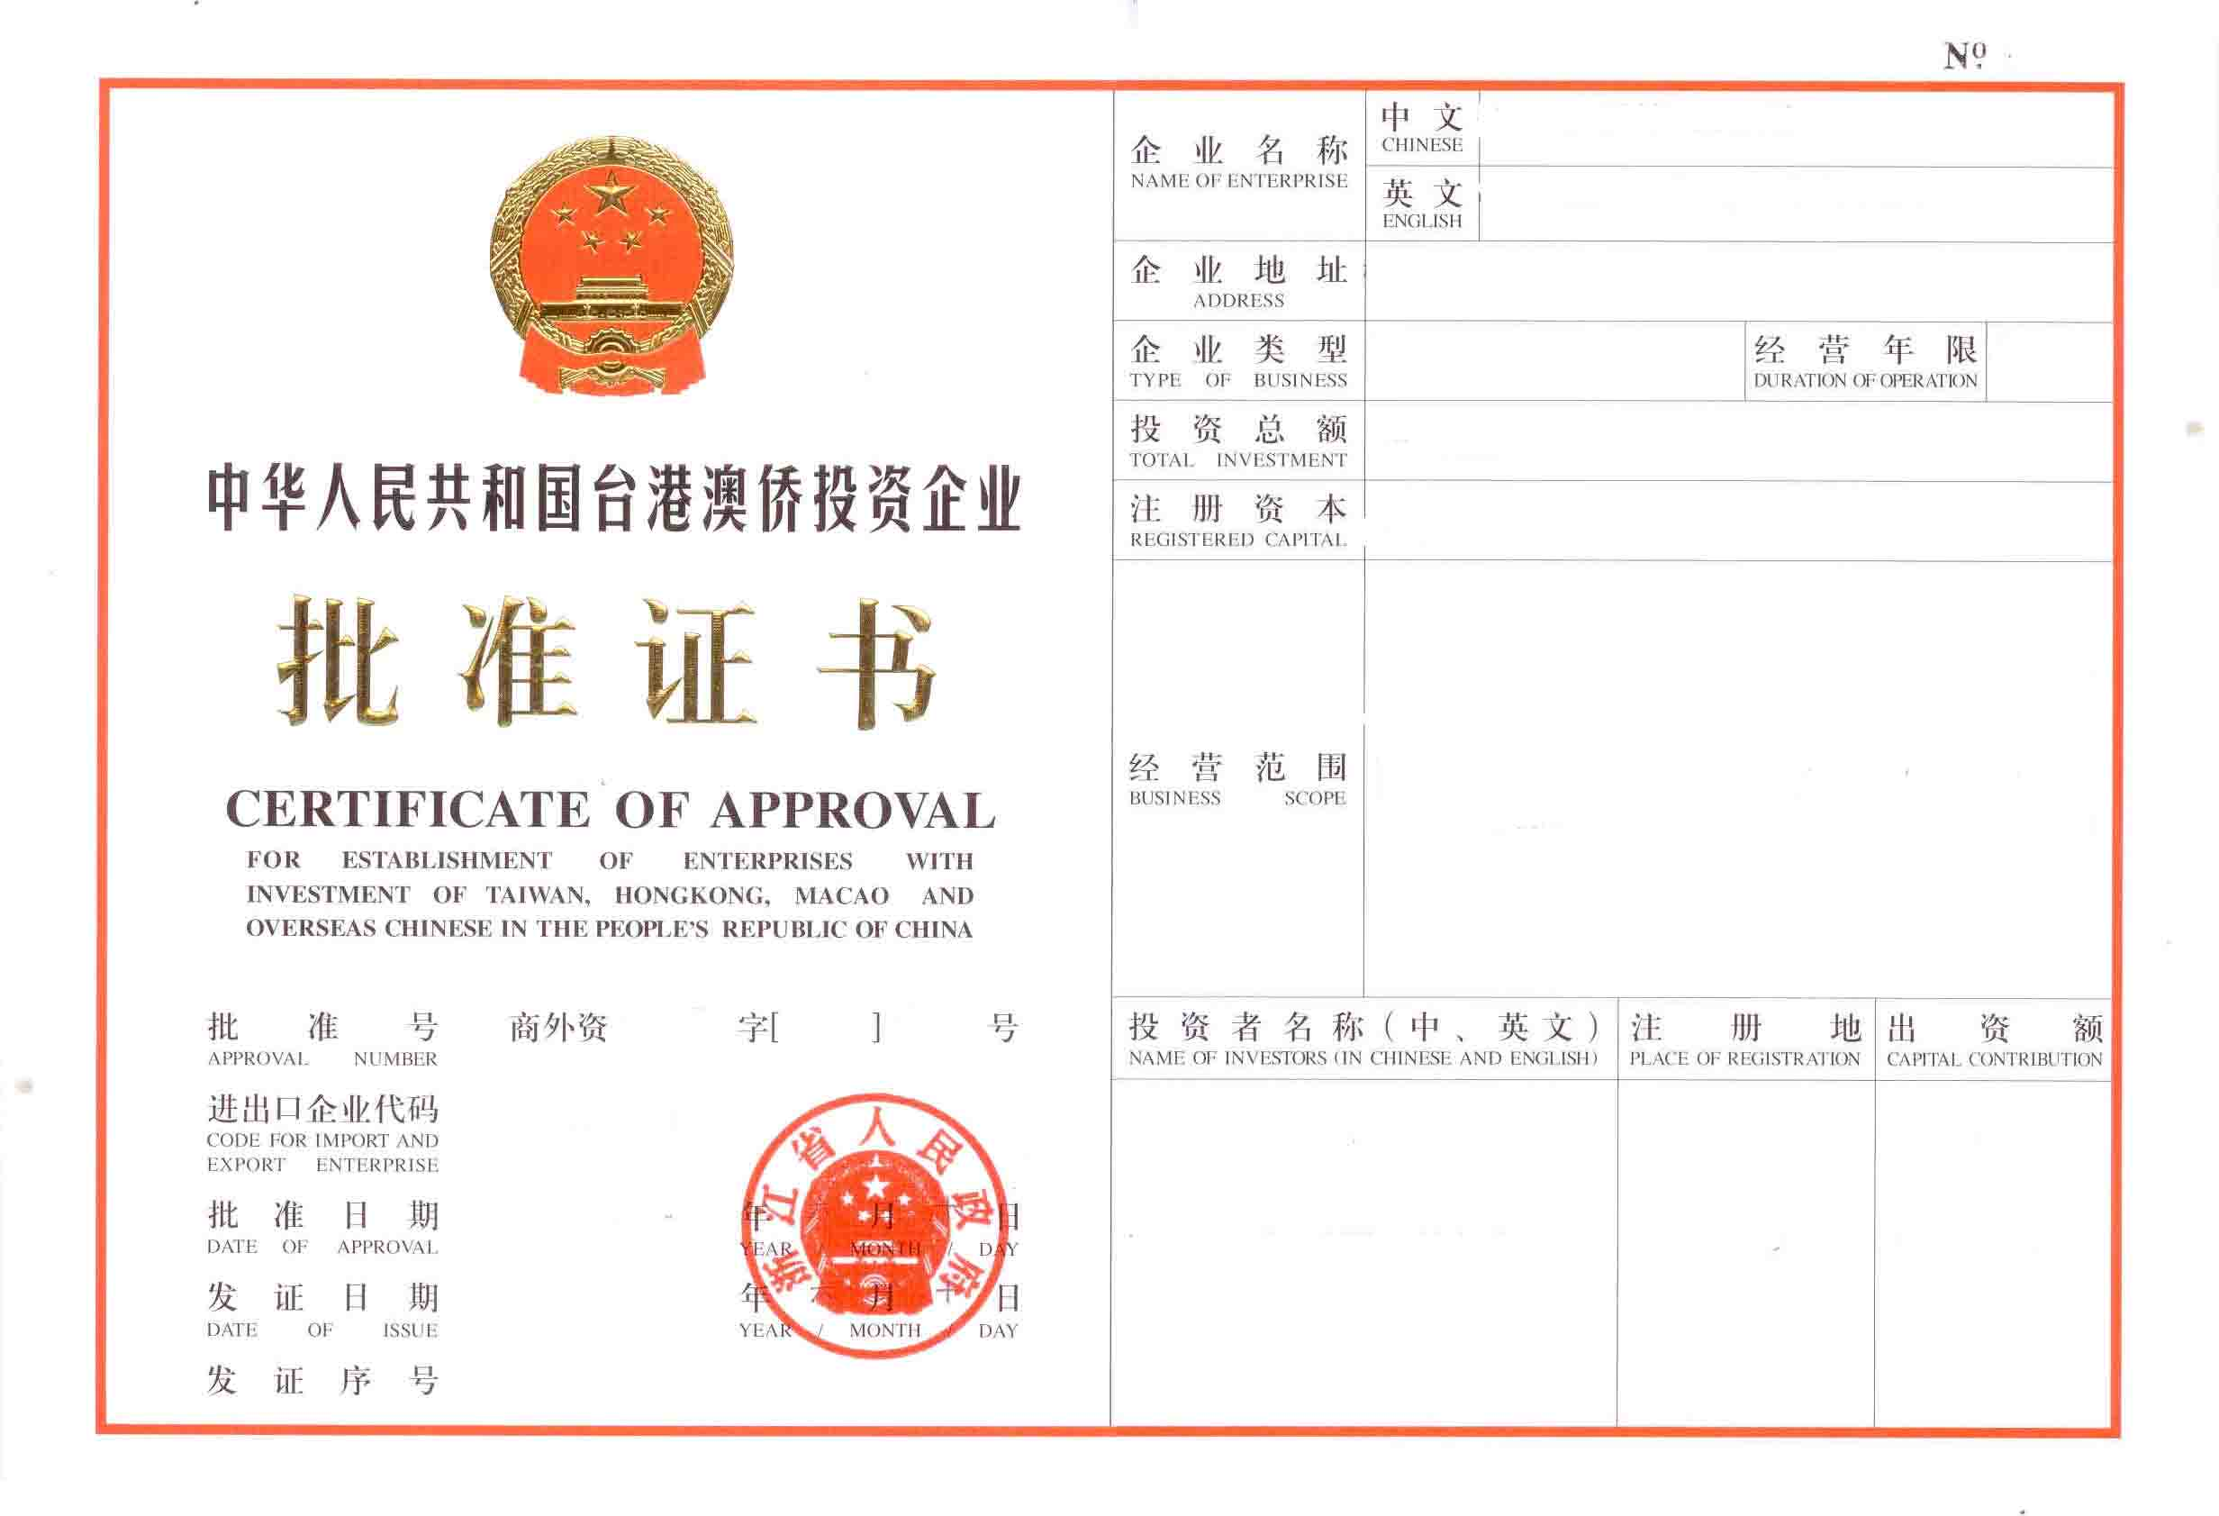
Foreign investors should submit application to the local AIC (Administration of Industry and Commerce). No processing fee is required and processing time is within 2 working days.
Step 2 – Certificate of Approval
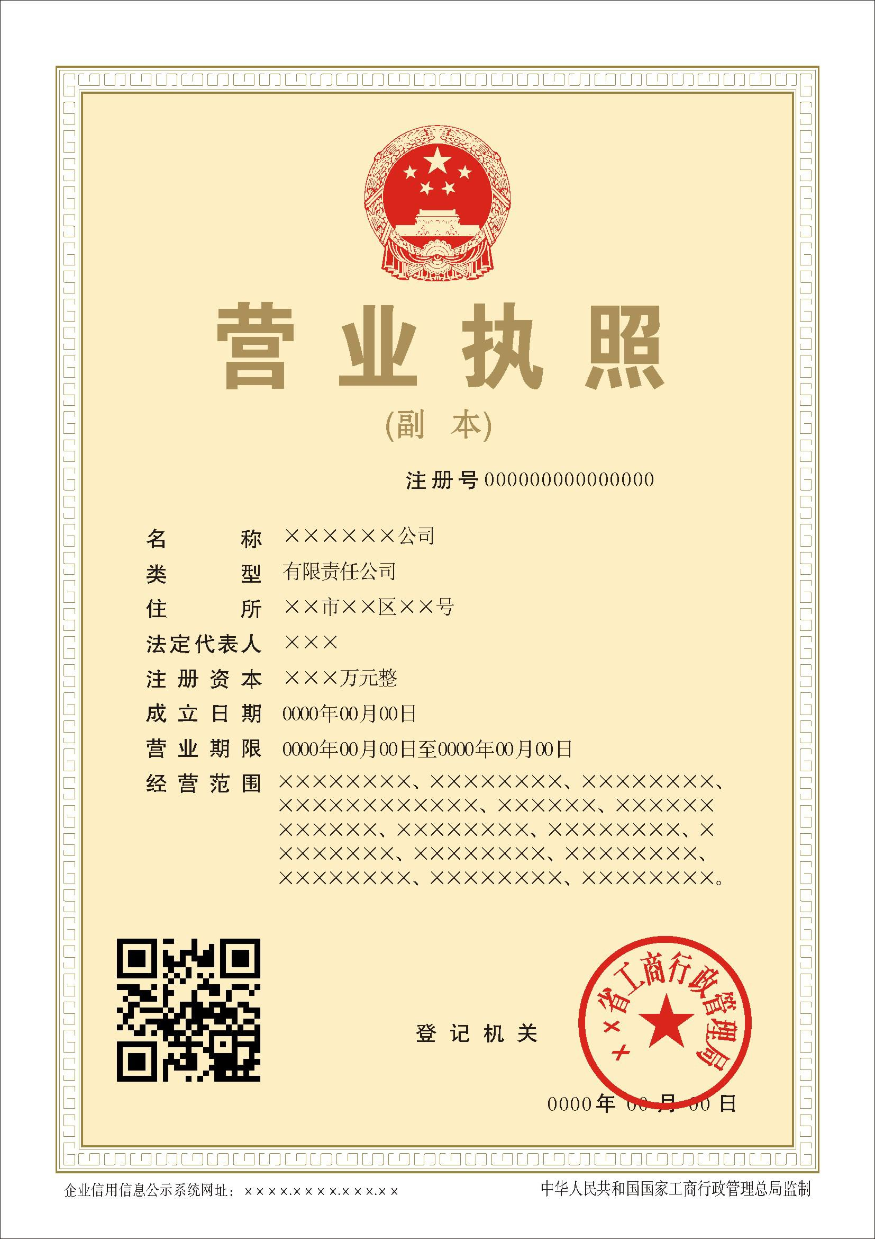
Foreign investors should submit written application for the establishment of the WFOE, feasibility study report, article of association, list of board of directors, appointment letters, lease agreement for the premises, reply of the pre-approval of of WFOE, incorporation documents of the WFOE investor and credit certificate of the WFOE investor issued within 3 months to the Department of Foreign Trade and Economic Co-operation at county, municipal or provincial level. No processing fee is required and processing time is 15-30 working days.
Step 3 – Apply for Business License
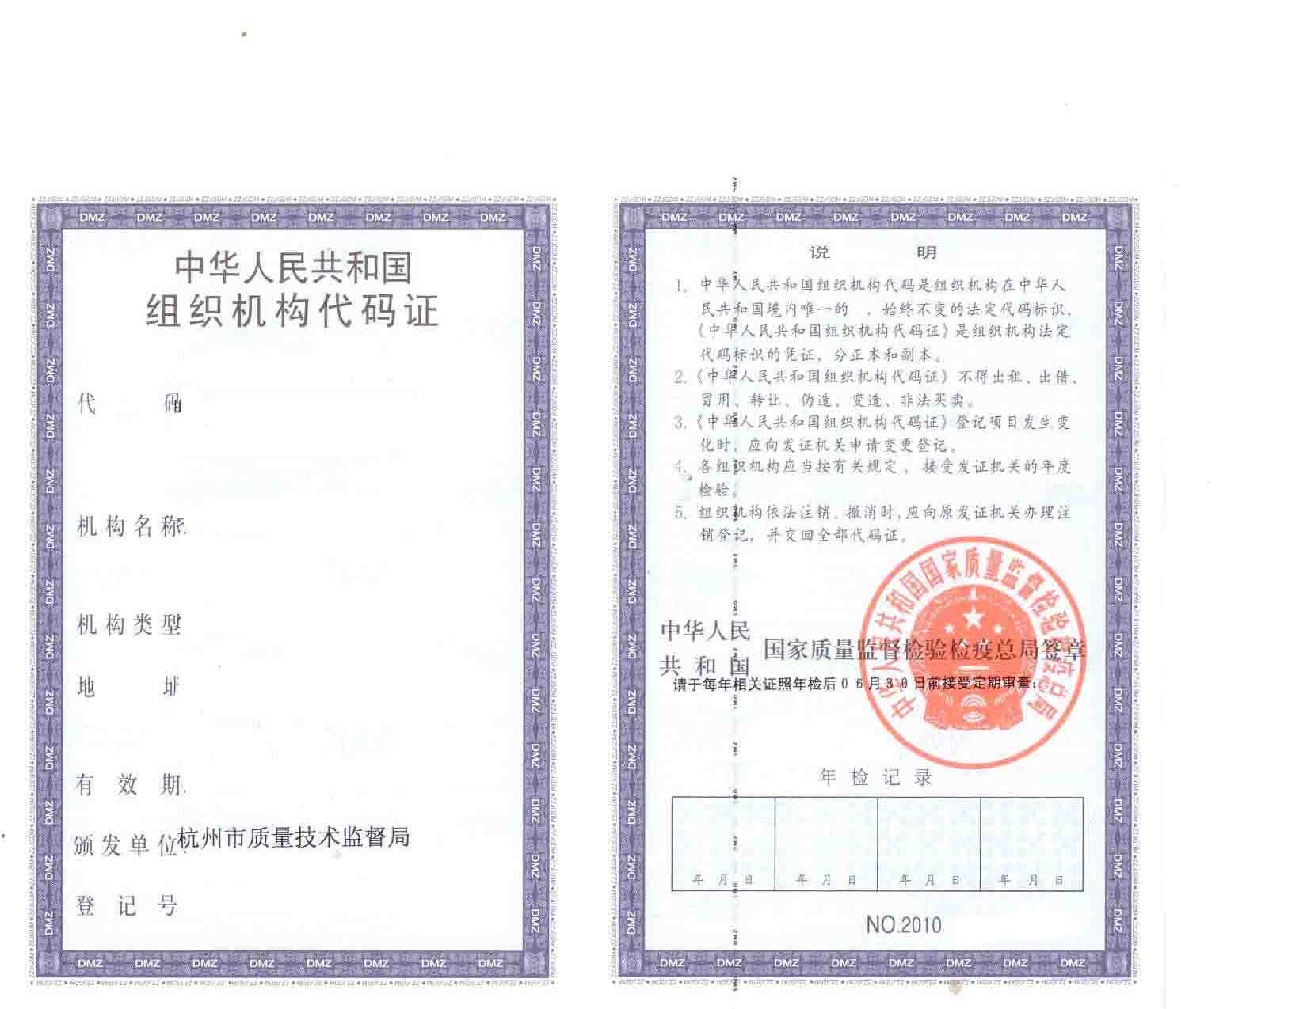
Within 30 days after obtaining the approval certificate, the foreign investor will need to register and apply for a business license for the WFOE from the local AIC. As part of this step, the foreign investor will need to submit similar documentation to the approval documentation for AIC filing purposes. The processing fee is related to registered capital and processing time is 15 working days.
Step 4 – Apply for Organization Code License and IC Card
The investor should go to State Bureau of Technical Supervision (The Administration Center of Organization Code) for the organization code license and IC card. Processing fee is RMB 90 and processing time is 1 working days after acceptance of registration.
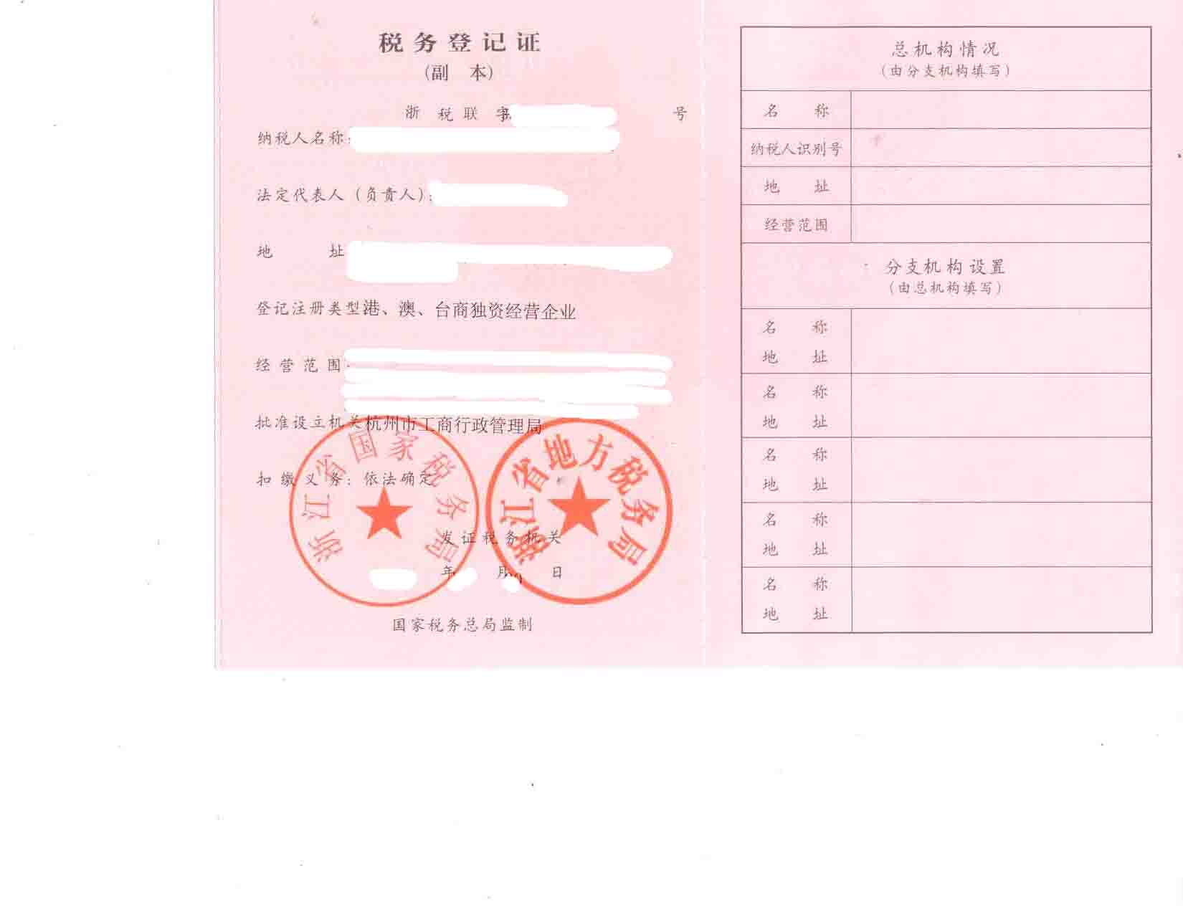
Step 5 – Engraving Registration for Official Seals at the State Public Security Bureau
Before engraving official seals (including but not limited to Company Seal, Financial Seal, Legal Representative Seal), the investors need to register at the State Public Security Bureau. Processing fee is not needed and processing time is within 1 working days.
Step 6 – Tax Registration
Then, the investor should go to the National/Local Taxation Bureau for tax registration. Processing fee is not needed and processing time is within 1 working days.

Starting from 2015, Chinese government issued a new policy called “one permit/five numbers registration model”. After fill out the one permit/five numbers registration form, investors are able to apply those above - mentioned licenses and registration together in Industry and Commerce Bureau.

Step 7 – Apply for Foreign Exchange IC Card at State Administration of Foreign Exchange
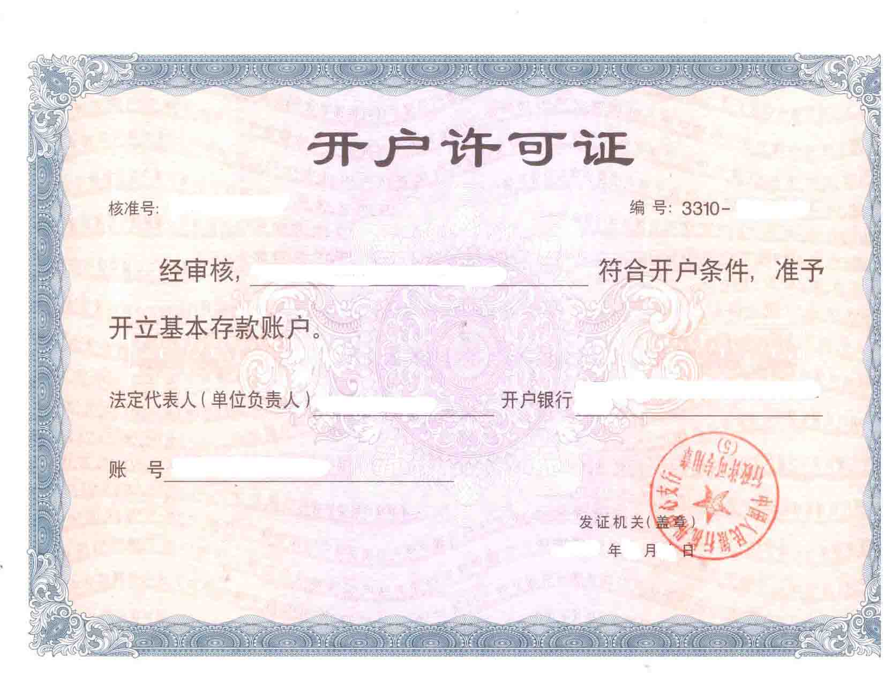
Since the operation of the WFOE must involve foreign exchange, investor should register at Local SAFE (State Administration of Foreign Exchange). No processing fee is required and processing time is 20 working days.
Step 8 – Opening of Bank Account
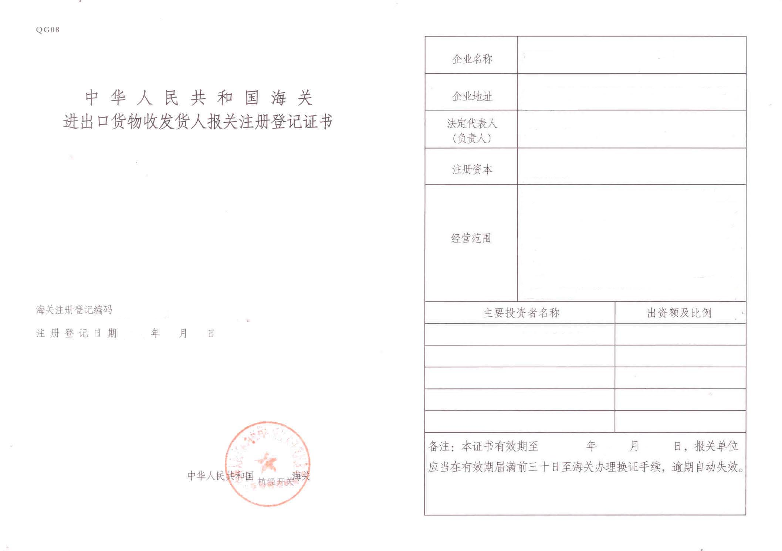
After Step 7, the investor could open a CNY bank account in any reputable bank. CNY account will be used for domestic operation. (Including but not limited to purchase material, pay house lease, etc.) After Step 8, the investor could open foreign currency bank accounts in any reputable bank. A foreign currency (usually USD or Euro) account will be used only for receiving registered capital from the investor, and multiple foreign currency accounts could be open for international operation. (Including but not limited to purchase material, pay consulting fee, etc.) For CNY account, the processing time is within 10 working days, and for foreign currency accounts, the processing time is within 1 working days, and the processing fee is different in different banks.
Step 9 – Obtain Import/Export License
After getting the CNY bank account, the investor could register at local Custom and apply for the import/export license. The processing fee is RMB 300, and the processing time is within 3 working days.
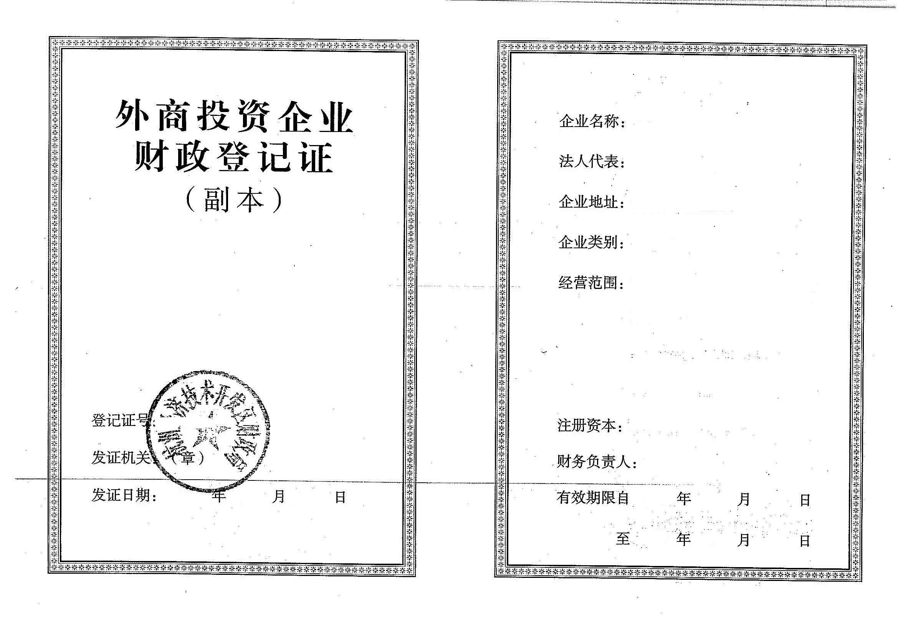
Step 10 – Obtain Certificate of Original
After getting the import/export license, the investor could register at local Administration of Quality Supervision, Inspection and Quarantine for the Certificate of Original. The processing fee is RMB 300, and the processing time is within 3 working days.
Step 11 – Registration for Financial License
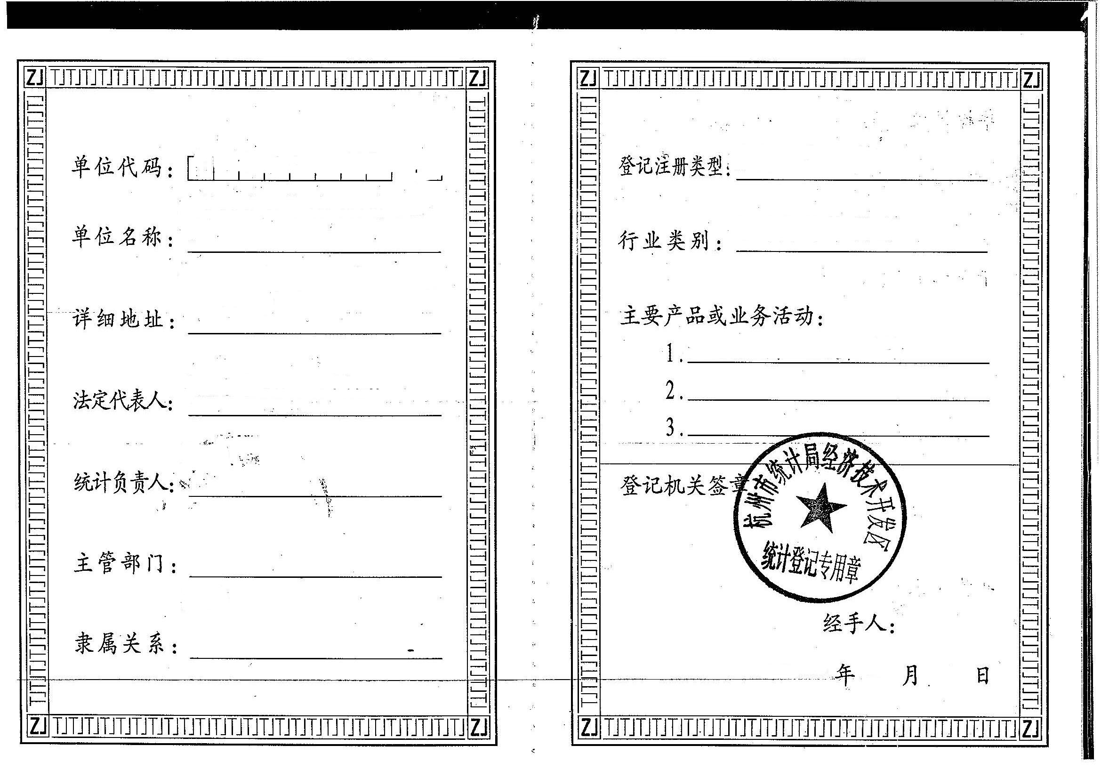
For the Financial License, investor should go to the State Financial Bureau. No processing fee is required and processing time is 1 days after acceptance of the registration.
Step 12 – Registration for Statistic and Audit License
Investor should register at Regional Bureau of Statistics of China for statistic and audit license. No processing fee is required and processing time is 2 days after acceptance of the registration.
Step 13 – Obtain General Tax Payer Status (optional, only for trading company)
After all these, investor could register at State Taxation Bureau and apply for General Tax Payer Status. Though no processing fee is required, this process could take up to 1 year time, depending on the requirements of the local State Taxation Bureau.

Additional Notes of WFOE
What is a WOFE?
A Wholly Foreign-Own Enterprise (WFOE) is a business entity formed by Chinese laws in China entirely with foreign capital and is under full foreign control and ownership. A China WOFE set up is a limited liability company and is taxed according to local legislation.
In China, different forms of WOFE co-exist:
- Trading WOFE
- Industrial WOFE
- Service WFOE
All have different registration criteria and are subject to different rules in terms of legal structure and tax
Why create a WOFE?
Wide range of business scopes, unlike RO (Representative Office), a WFOE can receive revenue in RMB, and issue RMB official Fapiaos (taxable receipts) to customers, and Proforma Invoice ( PI ) to overseas customers.
Independent operation: A WFOE can Independently carry out parent Company’s global strategy, with no consideration of Chinese partner factors like a JV, due to its wholly owned nature. The mother company has no liability risk as the WFOE is considered as an independent entity. A WFOE’s liability is limited to its capital investment.
What are the advantages of creating a WOFE?
- There are few restrictions on the activities of a China WFOE
- The normal term for a WOFE business license is 15 to 30 years, although extensions are available. However, a manufacturing WFOE can be 50 years, also open to extension.
- A China WOFE requires only one director (unless the investor sets up a Board of Directors, in which case the minimum number of directors is three). A director can be any nationality and can be resident anywhere. However, corporate directors are not permitted
- A China WFOE can be 100% foreign owned. China WOFE formation requires at least only one shareholder, who can be any nationality, but the shareholder cannot reside within China. Corporate shareholder(s) are permitted.
- A company secretary is not required for China WOFE registration.
- A China WOFE is eligible for legal duty exemptions if located in Free Trade Zones, Export Processing Zones
- Fairer calculation of business tax based on your turnover, while for corporate income tax, if the expenses and costs do not exceed your turnover, no tax will be charged.
- No requirements concerning building categories, you can either rent a building, or lease a greenfield and building up your own buildings
- As a WFOE, you can directly sign labor contracts with your employees.
What are the Disadvantages of WOFE?
- International entrepreneurs should prepare for China WFOE set up to be completed in four to six months, in case of a production WFOE, due to complex licensing procedures and bureaucracy.
- Incorporating a China WOFE is expensive. A China WOFE must pay a minimum 20% of the registered capital into a corporate bank account in the first three months of incorporation, the remaining 80% is to be paid within one or two years, if the registration capital is below or equal to USD 1 million. If the Registration capital is higher, the capital contribution schedule is longer. Under China company law, the minimum share capital for a company with multiple shareholders is just RMB30,000 (US$5K). However, to successfully register and operate a WOFE requires minimum RMB 100,000 - RMB 500,000 (or higher), depending on the industry and region within China.
- Capital Investment requirements. There will be minimum capital requirements to setup a WFOE according to different industries.
- A China WOFE must prepare audited accounts according to Chinese accounting standards
- Corporate directors are not permitted when setting up a China WOFE.
- A China WFOE is required to appoint a legal representative and a supervisor.
Why go through 5CGroup for setting up your WOFE?
Benefits to go through 5CGroup:
- An international team of lawyers, CPAs, more familiar with laws and regulations, both in China and abroad, good understanding of Chinese political and business culture, who can offer customers a whole package of solution service.
- Translation and interpretation, to Chinese all your documents
- Design the best strategy, customized WOFE, or other structure more suitable for you
- Based on professional consulting 5CGroup will give you the optimum corporate solution to fulfill international business objectives
- Unlike other firms, 5CGroup provide lifetime service for your company after setting up, in terms of legal, tax, management and HR consultation.
- Many years of experience of pleasant cooperation with local governments of all levels
- Many successful cases in difference cities of China, for customers from different countries.
How long does it take to set up a WOFE?
Complicated application process for registration. Usually, the whole process takes 4 to 6 months:
By 5CGroup, our time line to set up a service WFOE is around 4 weeks, and production WFOE around 8 weeks. For the WFOE who lease long term greenfield, it may take 6-10 months’.
How can I avoid paying unnecessary Taxes?
A WFOE is taxed on its profit gains (25%). To avoid or reduce Corporate Taxes there are two solutions:
- Balance invoices and expenses (salary, travel…) in order to have zero profit.
- Setting up an offshore holding company for all overseas bills, such as Hong Kong, BVI ( British Vergin Island ), etc.

Total cost for 5CGroup services:

Around 7,000 Euro for setting up a trading WFOE, and 5,000 to 6,000 Euro for a service WFOE:, depending on which city of China.

